Chapter 7
User Manual

A user guide or user's guide, also commonly known as a manual, is a technical communication document intended to give assistance to people using a particular system. It is usually written by a technical writer, although user guides are written by programmers, product or project managers, or other technical staff, particularly in smaller companies.
User guides are most commonly associated with electronic goods, computer hardware and software.
Our user guides contain both a written guide and the associated images. In the case of our application, it is usual to include screenshots of how the program should look. The language used is matched to the intended audience.
We have prepared our user manual according to various user roles, so a novice user can understand system very quick. There are basically 2 roles tied with system.
- Employee
- Admin

- Admin Panel

- Login Page

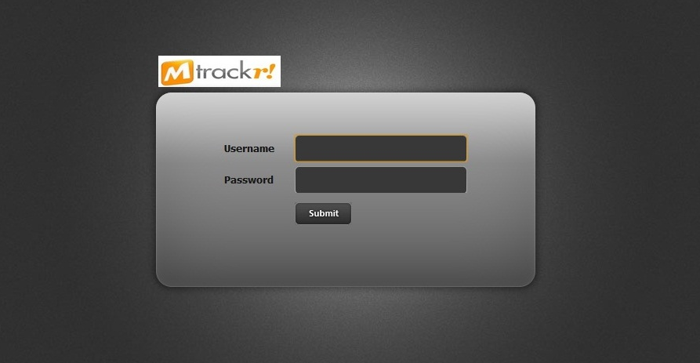

Figure 7.1 : Admin Panel Login Page

The above figure is of “mTrackr” Admin Panel Login Page. Here admin has to enter correct username and password and then click on ‘Submit’ button to log in. After successful login, Admin will be redirected on Welcome Page. If username and / or password is blank, then an alert box will be displayed. If username and / or password is incorrect, then an error message will be displayed.

- Welcome Page

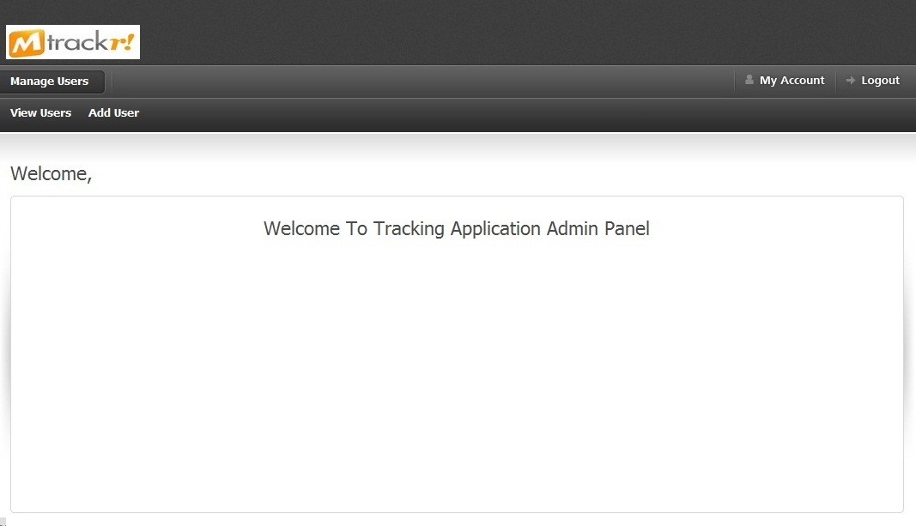

Figure 7.2 : Admin Panel Welcome Page

The above figure is of Welcome Page of Admin Panel. From here admin can go to View Users Page, Add User Page, Change Personal Detail Page, and Change Password Page. Admin can Logout from Admin Panel by Clicking on ‘Logout’ Image button.

- Add User Page
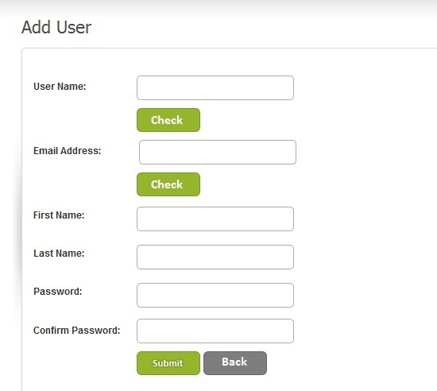

Figure 7.3 : Admin Panel Add User Page

The above figure is of Add User Page. From here Admin can add a new user of “mTrackr" by providing required details. By filling Username and clicking ‘Check’ button, admin can check whether that username is available or not. In same way, admin can fill Email address and check weather that Email address is available or not. An alert box will be displayed if admin click ‘Check’ or ‘Submit’ button without filling required fields, Invalid Email address or Password and Confirm Password do not match. By filling all valid data and clicking ‘Submit’ button, admin can add a new user and success message will be displayed to admin. By pressing ‘Back’ button, Admin can go back to Welcome Page.
- View Users Page

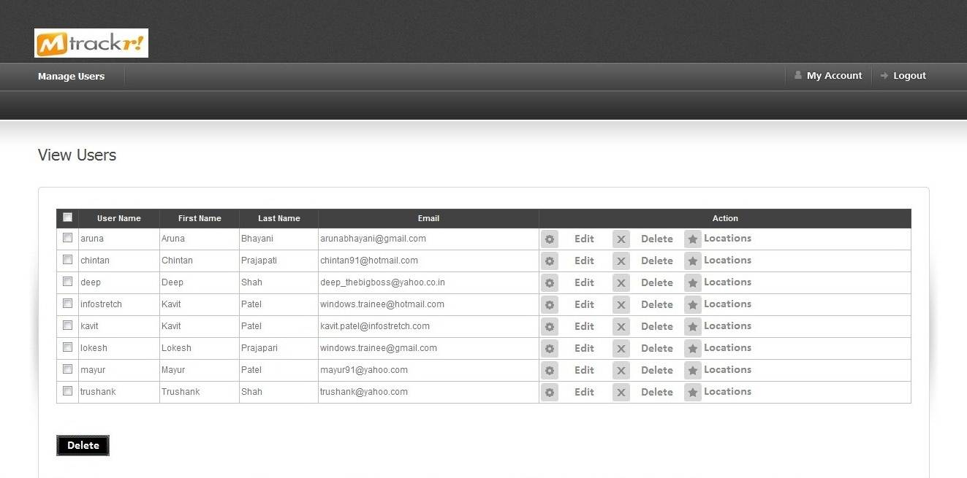

Figure 7.4 : Admin Panel View Users Page

The above figure is of View User Page. From here, admin can view list of all users of “mTrackr”. Admin can delete multiple users by selecting appropriate checkboxes and pressing ‘Delete’ button. A confirmation message will be asked to admin, if admin click on ‘OK’ button then selected users, their location information will be deleted from database. Admin can delete a single user by clicking ‘Delete’ link button from “Actions”.
A confirmation message will be asked to admin, if admin click on ‘OK’ button then that user and his / her location information will be deleted. By clicking ‘Edit’ link button from “Actions”, admin will be redirected to Edit User Page, where admin can edit user’s details. By clicking ‘Locations’ link button from “Actions”, admin will be redirected View User Location Page, where admin can view list of locations visited by user.

- Edit User Page

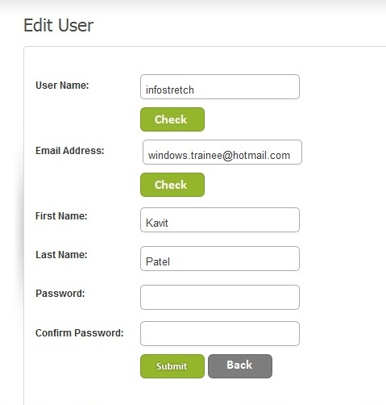

Figure 7.5 : Admin Panel Edit User Page
The above figure is of Edit User Page. From here Admin can edit any “mTrackr" user details. By filling Username and clicking ‘Check’ Button, admin can check whether that user name is available or not. In same way, admin can fill Email address and check weather that Email address is available or not. An alert box will be displayed if admin click Check or Submit Button without filling required fields , Invalid Email address or Password and Confirm Password do not match. By filling all valid data and clicking ‘Submit’ Button, admin can edit user and success message will be displayed to admin. By pressing ‘Back’ Button, Admin can go back to View Users Page.
- View User Location Page
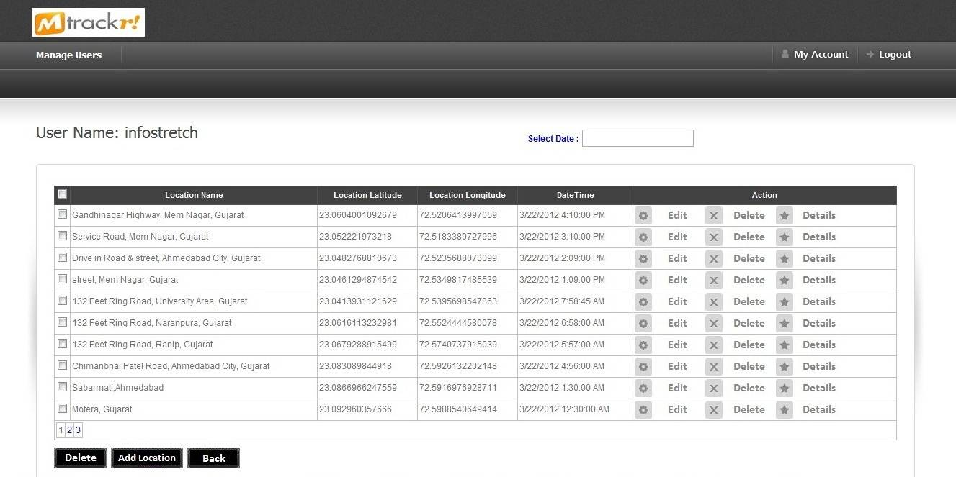

Figure 7.6 : Admin Panel View User Location Page

The above figure is of View User Location Page. From here Admin can view list of location visited by user. This list is sorted on descending order of visiting DateTime. Admin can view list of location of a particular date by selecting that date from Date Picker. Admin can delete multiple locations by selecting appropriate checkboxes and pressing ‘Delete’ Button. A confirmation message will be asked to admin, if admin click on “OK” button then selected locations information will be deleted from Database. Admin can delete a single user by clicking ‘Delete’ link button from “Actions”.
A confirmation message will be asked to admin, if admin click on “OK” button then that location information will be deleted. By clicking ‘Edit’ link button from “Actions”, admin will be redirected to Edit location Page, where admin can that edit location details. By clicking ‘Details’ link button from “Actions”, admin will be redirected to View Location Details Page, where admin can view that location details.
- Add Location Page
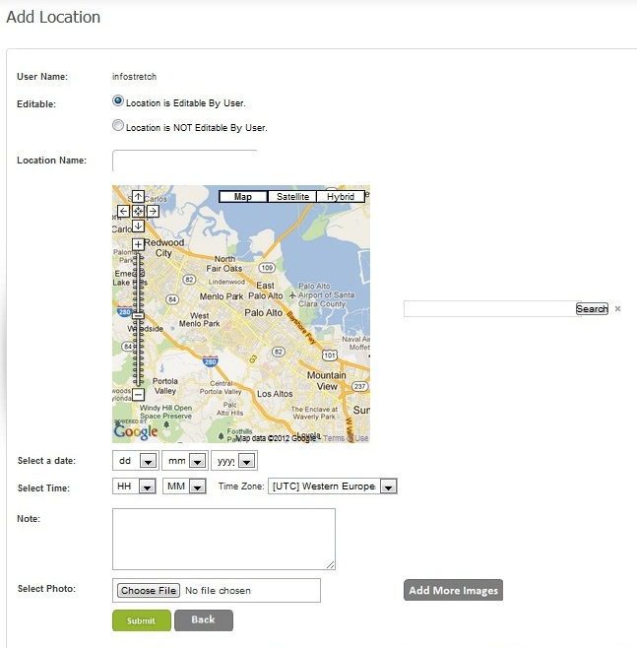

Figure 7.7 : Admin Panel Add Location Page
The above figure is of Add Location Page. From here Admin can add location of a user. Admin can select an option weather this location is editable by user or not. Editable location means user can edit any detail of that location from “mTrackr” Mobile Application. If location is not editable then user can only edit notes or photos of that location. Admin can search a location from Google map search box. Admin can also choose location by clicking on that location from Google map. Note is not a mandatory field. Admin can upload one or more photos for any location. An alert box will be displayed if admin click ‘Submit’ Button without filling required fields. A success message will be displayed if admin click on ‘Submit’ button after filling all correct details.
- Edit Location Page
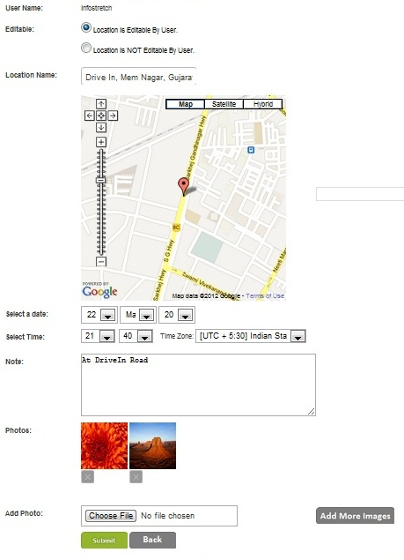

Figure 7.8 : Admin Panel Edit Location Page
The above figure is of Edit Location Page. From here Admin can edit location for a user. Admin can select an option weather this location is editable by user or not. Admin can change location by searching a location from Google map search box or by clicking on required location from Google map. Note is not a mandatory field. Admin can upload one or more photos for any location. Admin can also delete previously uploaded photo by clicking on ‘Delete’ button. An alert box will be displayed if admin click Submit Button without filling required fields. A success message will be displayed if admin click on submit button after filling all correct details.
- View Location Detail Page
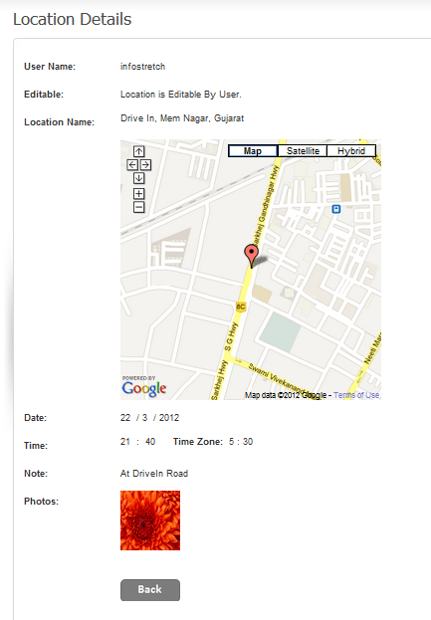

Figure 7.9 : Admin View Location Detail Page
The above figure is of View Location Detail Page. From here Admin can view all details of a location. Admin can view location name, location on map, location date, time, note and photos. Admin will be redirected to View Location List Page by clicking Back button.
- Change Admin Detail Page

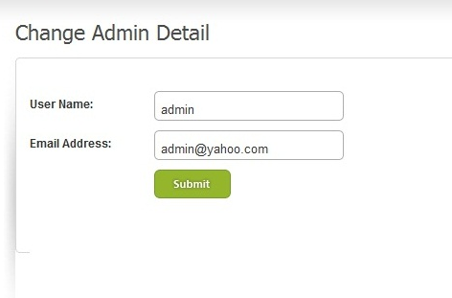

Figure 7.10 : Admin Panel Change Admin Detail Page

The above figure is of Change Admin Detail Page. From here admin can change his / her username and / or Email address. If username and / or Email address is blank, then an alert box will be displayed. When admin will click ‘Submit’ button after filling valid data, a successful message will be displayed.

- Change Admin Detail Page

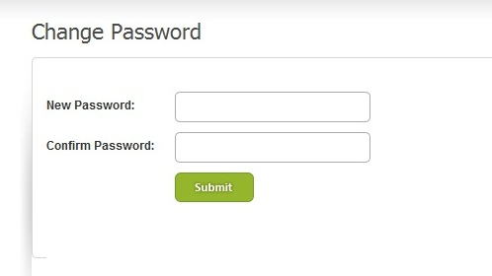

Figure 7.11 : Admin Panel Change Password Page

The above figure is of Change Password Page. From here admin can change his / her password. When admin will click ‘Submit’ button after filling valid password and confirm password, a successful message will be displayed and admin password will be updated in database. If password and / or Confirm password is blank, then an alert box will be displayed.

- Mobile Application

- Main Screen



Figure 7.12 : Windows Phone Main Screen
The above figure shows main screen of a Windows Phone. It contains “Tiles”. A Tile is a link to an application displayed in Start. The Tile is created when a user pins an application to Start by pressing and holding the application's icon in the Applications List. Tapping a pinned Application Tile navigates the user to the application’s opening page.
- Loading Screen



Figure 7.13 : Mobile Application Loading Screen
The above figure shows Loading screen of “mTrackr” Mobile application. This screen will be displayed when user will click on “mTrackr” tile or “mTrack” menu from Application Hub.

- SignIn Page

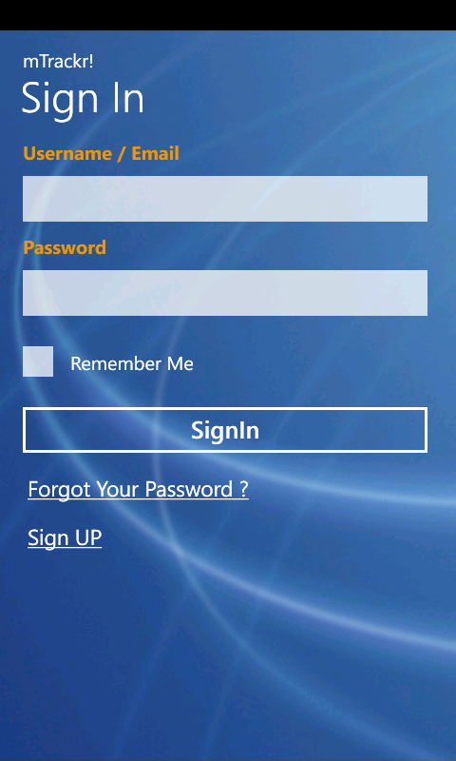

Figure 7.14 : Mobile Application SignIn Page
The above figure shows SignIn Page of “mTrackr” Mobile application. Here user has to enter correct username and password and then click on SignIn button to log in. After successful login, user will be navigated on Home Page. If username and / or password is blank or incorrect, then an error message will be displayed.

- SignUn Page

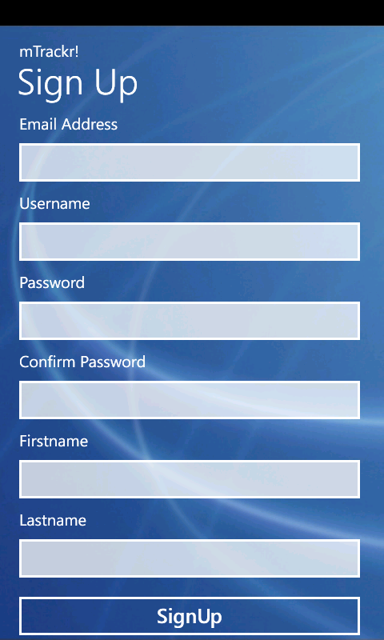

Figure 7.15 : Mobile Application SignUp Page
The above figure shows SignUp Page of “mTrackr” Mobile application. Here user has to enter username, email address, password, confirm password, first name and last name. An error message will be displayed if username and / or email address is already exist or any field is kept blank. A user will be navigated to Home page after successful SignUp.

- Forgot Password Page



Figure 7.16 : Mobile Application Forgot Password Page
The above figure shows Forgot Password Page of “mTrackr” Mobile application. Here user has to his / her correct email address to recover his / her password. An error message will be displayed if email address is incorrect. An email containing user’s password will be sent to his / her email address if email address is correct.

- Home Page

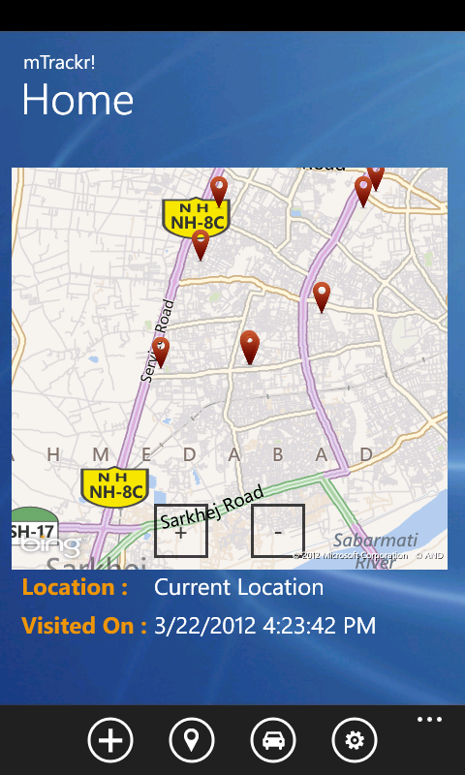

Figure 7.17 : Mobile Application Home Page
The above figure shows Home Page of “mTrackr” Mobile application. Here user can view his / her current location and nearby by locations which he / she visited in past. User can click on any pushpin and view location name and Datetime on which location was visited. User can navigate to “Add Location” Page, “Browse Location” Page, “Route” Page or “Setting” Page by clicking respective icon from Application Bar.
- Add Location Page

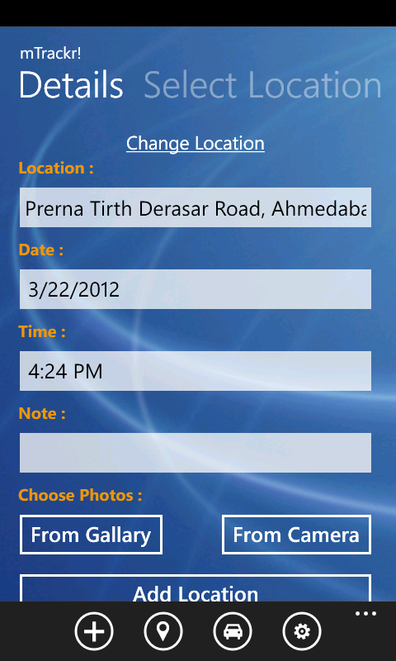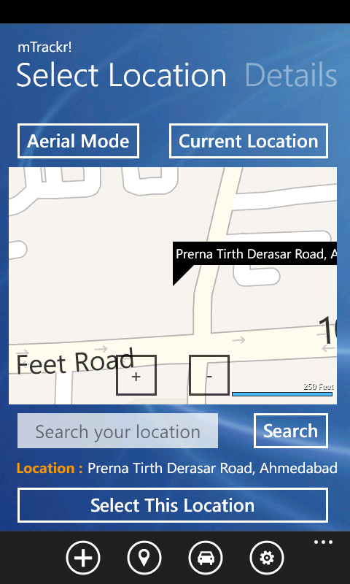

Figure 7.18 : Mobile Application Add Location Page
The above figure shows Add Location Page of “mTrackr” Mobile application. When user is navigated to this page, details of current location will be loaded automatically. User can change this location by selecting any other location from map. User can select any location from map by searching location name in search box or by holding any location on map. User can also change map mode (Aerial Mode to Road Mode or Road Mode to Aerial Mode). User can add photos from gallery or capture from camera. A success message will be displayed to user if he / she click on “Add Location” button after filling all correct information.

- Browse Locations Page

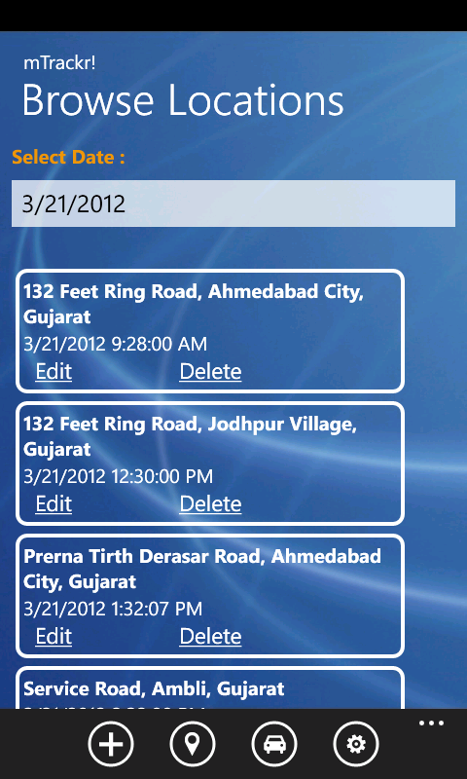

Figure 7.19 : Mobile Application Browse Location Page
The above figure shows Browse Location Page of “mTrackr” Mobile application. When user is navigated to this page, list of locations of current date will be loaded. User can select any other date from date picker to view list of locations of any other date. User can View location details by clicking on Location Name. User can Edit any location by clicking on “Edit” link. User can delete location detail by clicking “Delete” link.

- Edit Location Page

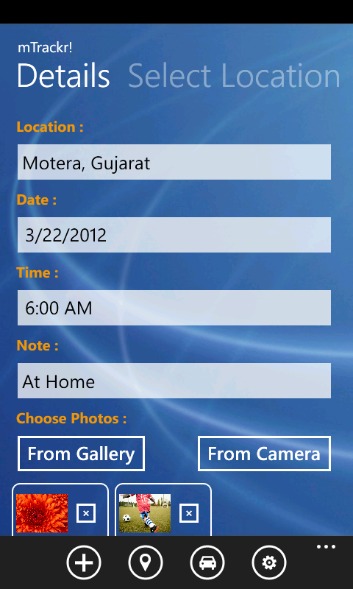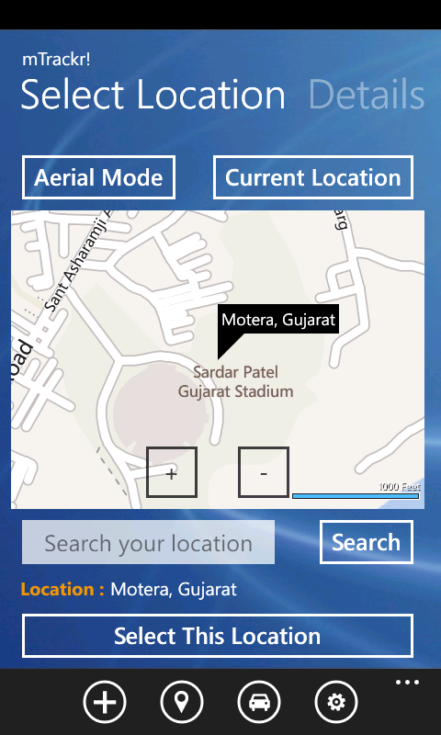

Figure 7.20 : Mobile Application Edit Location Page
The above figure shows Edit Location Page of “mTrackr” Mobile application. When user is navigated to this page, details of location will be loaded automatically. User can change this location by selecting any other location from map. User can select any location from map by searching location name in search box or by holding any location on map. User can also change map mode (Aerial Mode to Road Mode or Road Mode To Aerial Mode). User can add photos from gallery or capture from camera. User can also delete previously uploaded photos. User can change Location Name, Date, Time or Note .A success message will be displayed to user if he / she click on “Update Location” button after filling all correct information.

- View Location Page

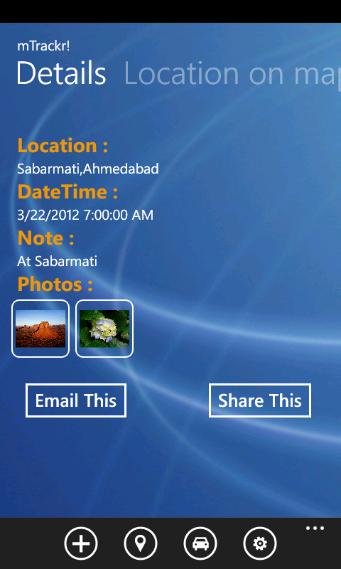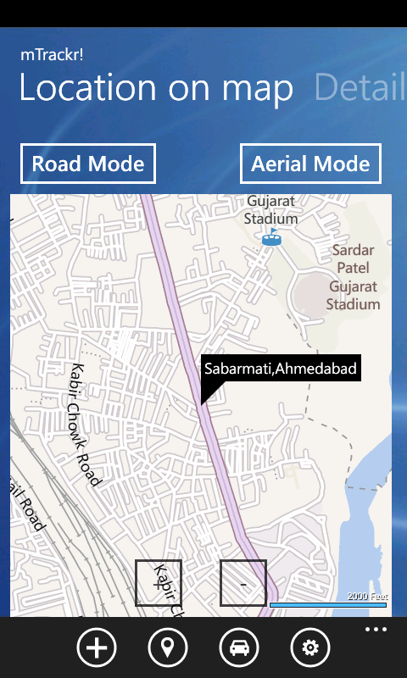

Figure 7.21 : Mobile Application View Location Page
The above figure shows View Location Page of “mTrackr” Mobile application. When user is navigated to this page, user can view Location Name, Date,Time ,Photos and Notes for that location.User can also view this location on map. User can change map mode from Aerial to Road or Road to Aerial. User can Share this location information via Social Networks like Facebook, Twitter. User can also Email this location information.

- Route Page

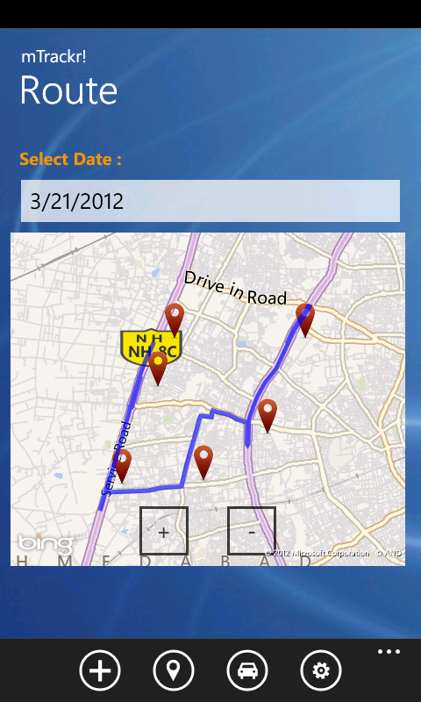

Figure 7.22 : Mobile Application Route Page
The above figure shows Route Page of “mTrackr” Mobile application. When user is navigated to this page, Route of current date will be loaded. User can select any other date from date picker to route of locations of any other date. User can View location details by clicking on location pushpin on map.

- Setting Page

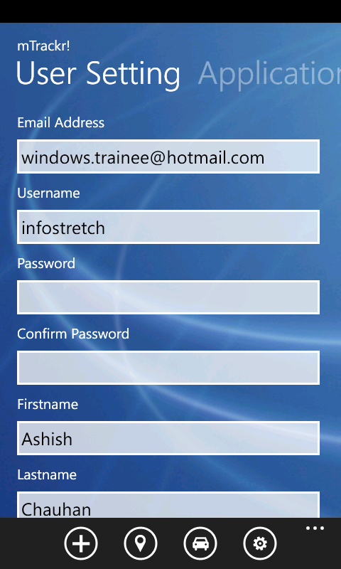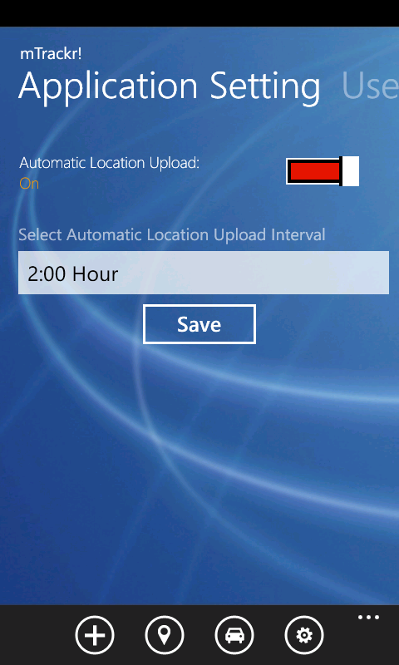

Figure 7.23 : Mobile Application Setting Page

The above figure shows Setting Page of “mTrackr” Mobile application. Here user can change User Specific Settings and Application Specific Settings. User can enter new username, email address, password, confirm password, first name or last name. An error message will be displayed if username and / or email address is already exist or any field is kept blank. User can change Automatic upload interval from Application Specific Settings. User can also turn on / off background agent.
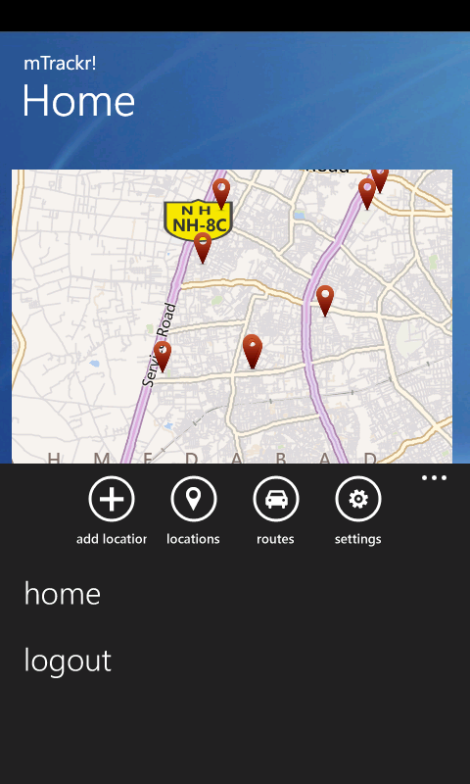

Figure 7.24 : Mobile Application Home Page with Application Bar
User can logout from the application by clicking on “logout” from application Bar. When user will click on “logout” then Background agent will be stopped and user will be navigated to SignIn page.

